In 2020, mobile apps are projected to generate 188.9 billion U.S. dollars in revenues via app stores and in-app advertising.

**Mobile app trends**

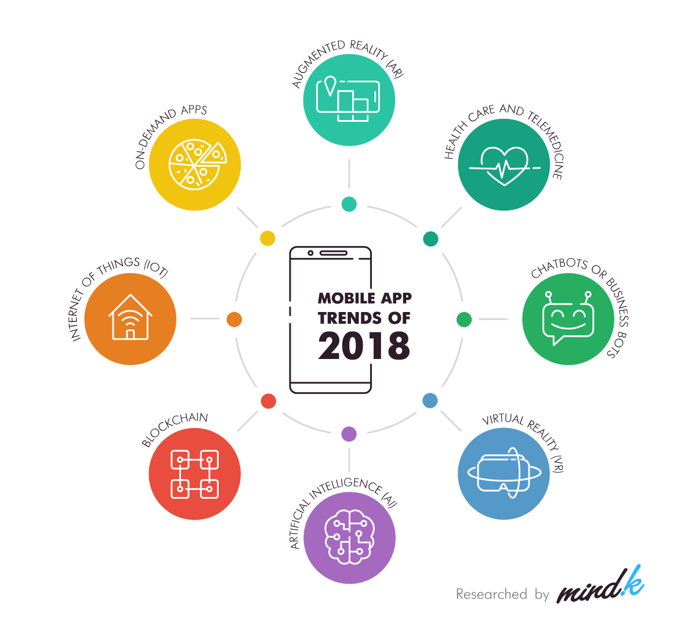

**App Ideas 2020**

**On-Demand Car Wash App**

It is one of the most popular and trending app ideas for 2020. Using this app, customers can order a car wash from their preferred service provider from their home at a specific time.

Mobile Wash is a popular on-demand car wash app. If you want to develop this kind of mobile app, you can contact to leading on-demand app development company.

**Real-time Car Sharing App**

A real-time car-sharing app enables a user to list out their car along with the destination name where they are heading. On the other hand, a user who is also heading to the same destination can enter their details and look out for users with cars.

**Public Transport Helper (Applicable on Tier1 Cities)**

It is a cool mobile app idea that will be useful to people across the globe. When visiting a new place or a city, people are unfamiliar about how they can reach their desired location.

In these situations, public transport-helper will provide the most relevant options such as schedule, timing, price, etc. to the users so that they can reach the destination with ease.

Here, the app can also provide the most preferred transport option to the user in a particular situation.

**Grocery Compare App**

This app will allow a user to enter a list of all items and then compare the rates of these items at different grocery stores present in their region. The app will then list out all the awesome deals that users can grab instantly.

For instance, if you want to buy potatoes, then the app will list out all the stores where the item is available at a discounted rate. Currently, there are a wide number of grocery delivery apps available in the market, but a grocery comparison app can set you apart from all the competitors.

**Price compare App**

Using this app, you will be able to check the price of a product on different eCommerce sites that are available on the internet. Here, you just have to enter the name of the product, and the app will instantly list the price of the product on various sites.

**Voice Language Translation App**

Globalization and the ever-expanding reach of the Internet have joined people across the globe. Still, the language remains to be a hurdle.

An app that can translate a language with other country’s native language and vice versa will be beneficial to these travelers.

**Virtual Interior Designer App**

Decorating your home is a very challenging task. For decoration, you have to figure out different items that can be placed in your room. To resolve this, an AR app can help. This app enables you to take a photo of a room or any other place you want to decorate.

Later, it enables you to visualize your room by placing various 3D items such as colors, objects, wall stickers, curtains, etc. Moreover, the app also lists all the nearby places from where you can purchase these items.

**Gift Suggestions Provider**

This app checks the entire social media profile of your friend and then provides the most suitable gift idea depending on the content that they have posted.

**Social Networking to buy & sell items**

This app will work just as Facebook, however, with some of the additional features, such as connecting with your current friends to buy or sell items online. Moreover, the app will also enable you to offer suggestions regarding different products and search & buy items as per your friend’s recommendations.

**Food Donation App**

Around one-third of the total world’s food gets wasted in the junkyard. However, a billion people in the world remain hungry daily. In case food waste was a country, it would rank at number three in terms of carbon emissions after the United States and China.

Hence, a food donation app can help to resolve this issue across the globe. It will be highly beneficial for restaurants also. Using this app, restaurants can connect with nearby charities and NGOs. These organizations will then donate food to needy people.

**Subscription Organizer App**

Various users around the world are subscribed to different services such as Spotify, Netflix, Amazon Prime, and diverse other entertainment and utility apps.

A subscription organizes app will keep a record of all these subscriptions & bills and notify the user before the payment date. Moreover, the app can also consists of a built-in payment system for automatic bill payments.

**Digital Mall Navigation App**

This app will save a digital map of shopping malls in a particular region and it is beneficial to navigate in the mall and the directions heading towards it. It will be especially beneficial for big malls where users can easily check the location of the restaurant, store, bathroom, cinema, or status in the parking lot.

**Bike servicing app**

A door-step bike servicing platform and application which will use technology for the convenience of two-wheeler owners by providing them a transparent connection with high-quality vehicle maintenance providers. The platform can provide assisted door-step pick-up and drop, an in-built inventory management system that enables reduction of waiting-time, smarter stock allocation, an order management system etc.

**Travel-planning app**

This app will plan your ultimate trip. All you have to do is fill in the information like your budget, the scenery you like, weather, activities and other specifics that are the most appealing to do in your vacation and the app will find the ultimate destination and the time of the year when you can go.

**Pregnancy-helper app**

This is one of the pregnancy help app ideas, which will aid pregnant women with all pregnancy-related advice and answers that are put in by those professionally qualified. It can also connect with a shopping segment that is exclusive to soon-to-be-mothers

**On-demand fuel-delivery app**

A person who needs fuel for their vehicle without needing to go to the fuel station. The person can select the location where their car or the app can tag their location. A fuel truck driver can navigate to the tagged location with the help of the inbuilt map in the app. He will refuel the car while making sure all the safety regulations are maintained.

Source

<https://www.mindk.com/blog/best-app-ideas-for-your-business-2018/>

<https://www.gurutechnolabs.com/trending-app-ideas-for-business/>

<https://www.intelegain.com/app-ideas-for-startups-to-launch-in-2020/>